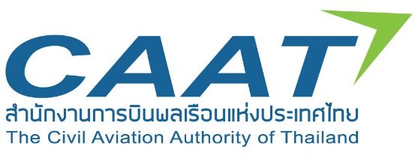
Responses to ICAO’s Proposal for the First Edition of Annex 16, Volume IV
Standards and Recommended Practices (SARPs) for CORSIA

Airline/Company

No | Page/Section | Clause | Comments

